## Overall Project status from Start to End

Report Date 2025-03-06 Project Type :Non Construction

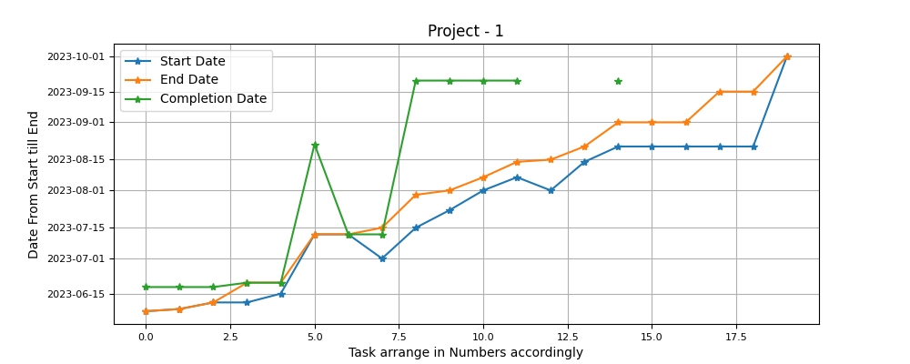

Project Detail View from start untill today can be observed. Star Marked are Tasks According to there Planned, Start and End Date and Actual Completion. Variance between the Planned Closed date and Actual Closed Date are clearly visible.

## Progress Delayed Items

##### Following items effected the progress performence

|  |  |  |  |
| --- | --- | --- | --- |
| Project Task Name | End Date | Completion Date | Extra Days |
| Subtask 1 | 2023-06-07 | 2023-06-18 | 11 days, 0:00:00 |
| Subtask 2 | 2023-06-08 | 2023-06-18 | 10 days, 0:00:00 |
| Subtask 3 | 2023-06-11 | 2023-06-18 | 7 days, 0:00:00 |
| Subtask 6 | 2023-07-12 | 2023-08-22 | 41 days, 0:00:00 |
| Subtask 9 | 2023-07-30 | 2023-09-20 | 52 days, 0:00:00 |
| Subtask 10 | 2023-08-01 | 2023-09-20 | 50 days, 0:00:00 |
| Subtask 11 | 2023-08-07 | 2023-09-20 | 44 days, 0:00:00 |
| Subtask 12 | 2023-08-14 | 2023-09-20 | 37 days, 0:00:00 |
| Subtask 15 | 2023-09-01 | 2023-09-20 | 19 days, 0:00:00 |